This homework assignment is based on Chapter 04.

**There are 3 projects, each worth 33.3%**

**Project #1**

**#1 print screen the output with the code below here.**

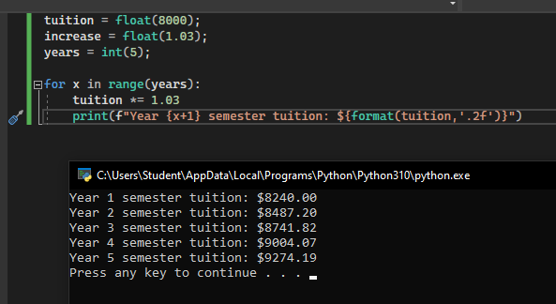

**Project #2**

**#2 print screen the output with the code below here.**

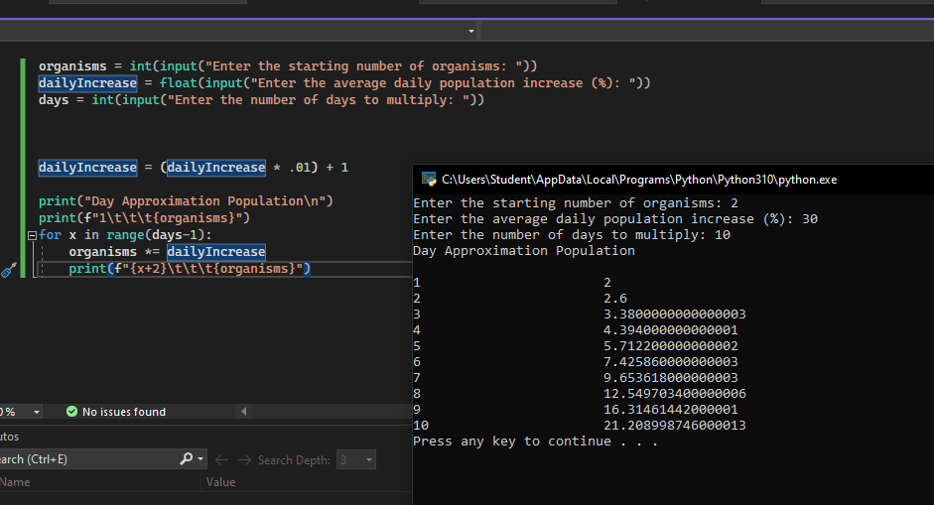

organisms = int(input("Enter the starting number of organisms: "))

dailyIncrease = float(input("Enter the average daily population increase (%): "))

days = int(input("Enter the number of days to multiply: "))

dailyIncrease = (dailyIncrease * .01) + 1

print("Day Approximation Population\n")

print(f"1\t\t\t{organisms}")

for x in range(days-1):

organisms *= dailyIncrease

print(f"{x+2}\t\t\t{organisms}")

**Project #3**

**#3 print screen the output with the code below here.**

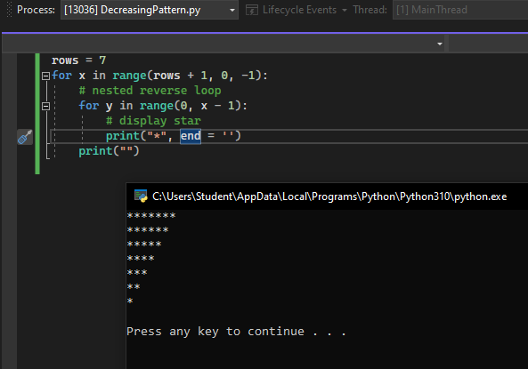

rows = 7

for x in range(rows + 1, 0, -1):

# nested reverse loop

for y in range(0, x - 1):

# display star

print("*", end = '')

print("")